**District Summary**

This data provides a broad snapshot of the district as a whole. This should be compared with previous years for changes in number of schools, and student enrollment, to determine needs such as additional schools and staffing and see trends in enrollment.

This data can also be compared to data from schools in other districts, across the state, and national averages.

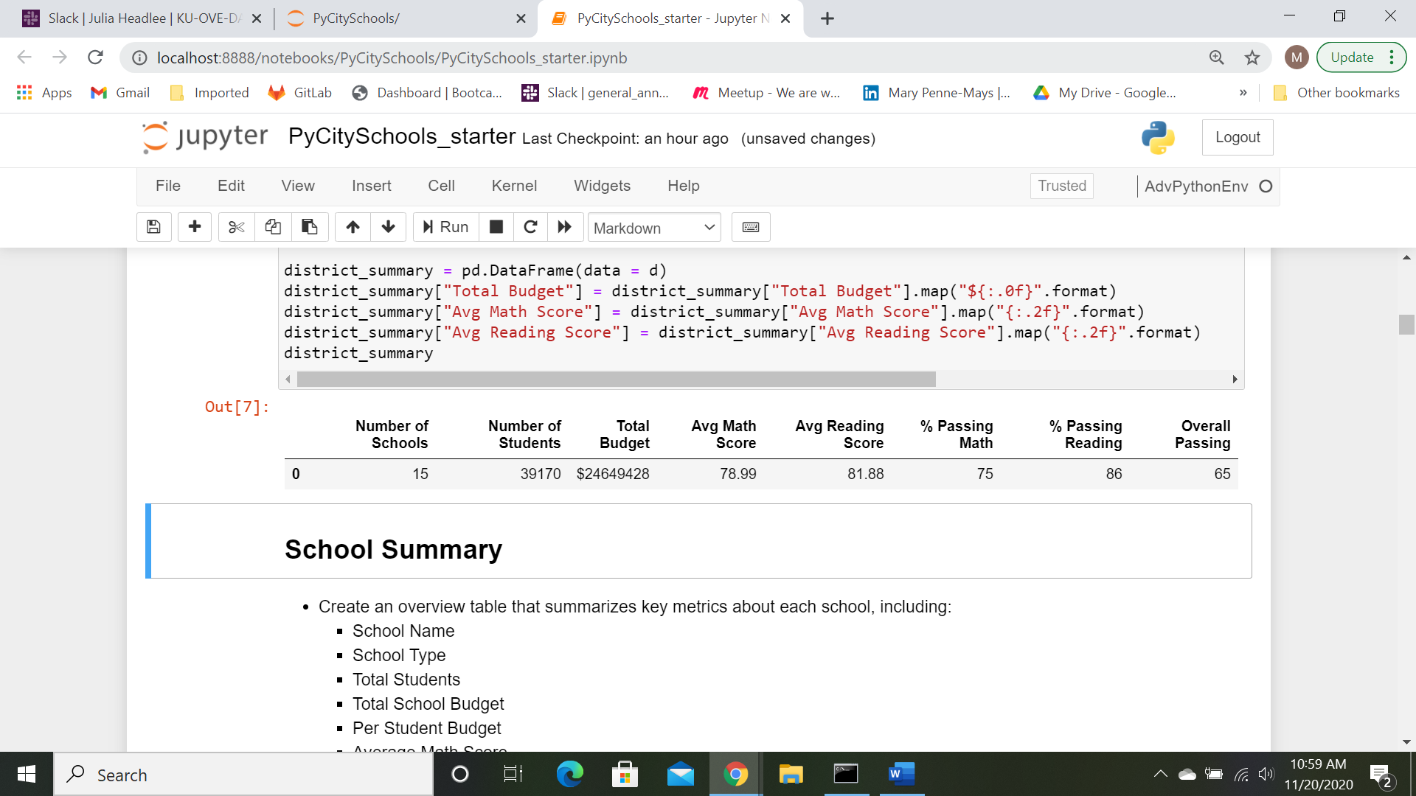

**School Summary**

This provides a base for comparison of schools within the district. A spreadsheet, schoolSummary.csv, is provided with all the schools included. Further analysis of this data will be included below.

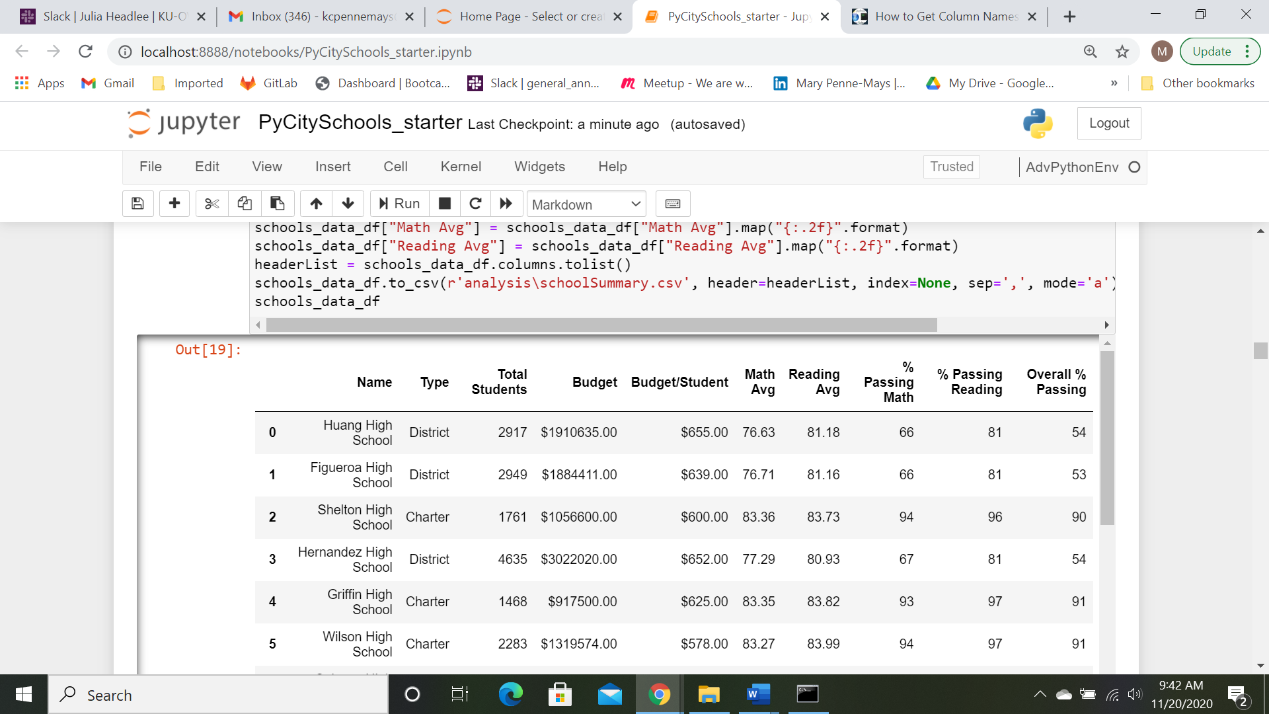

**Top Performing Schools**

From looking at this list, it is notable that all of the top performing schools are Charter schools, and all the testing percentages are in the upper 10 percent range. The school sizes all fall in the mid-size range.

For complete list of schools, sorted by performance, see the file, SchoolPerformance.csv

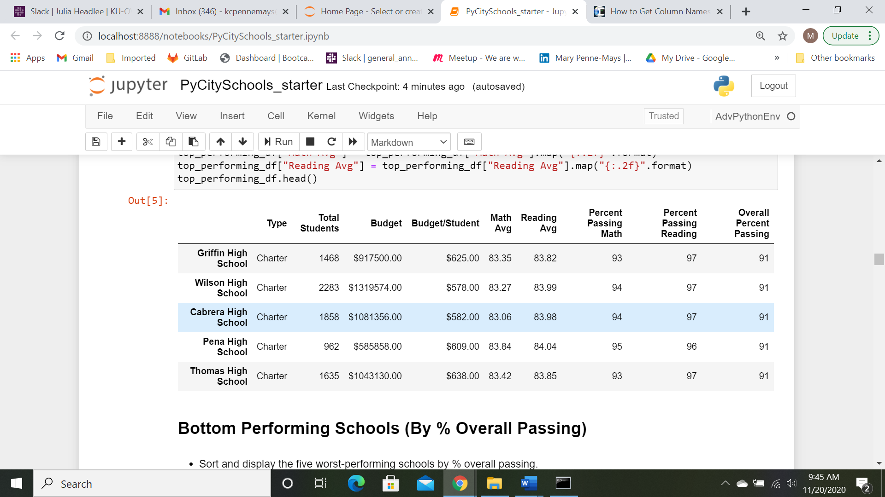

**Bottom Performing Schools**

The 5 lowest performing schools are all District-run schools. School size is larger than the highest performing schools. While the reading scores appear in an acceptable rang, the math scores are low, and the significant drop in the overall passing seems to indicate that students may be getting placed into focused ‘subject tracks’.

The budget per student is actually higher for these schools than the high performing schools. This could possibly be due to types of programs that the district must provide for students with special needs that charter schools may not be providing.

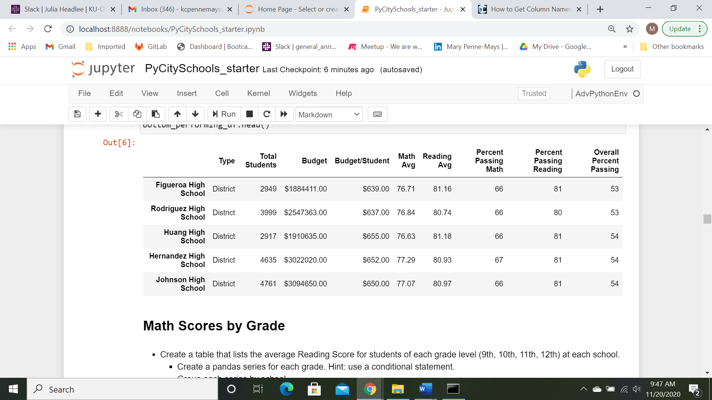

**Math Scores by Grade**

Looking at math scores by grade, in each school, there is little variation from year to year.

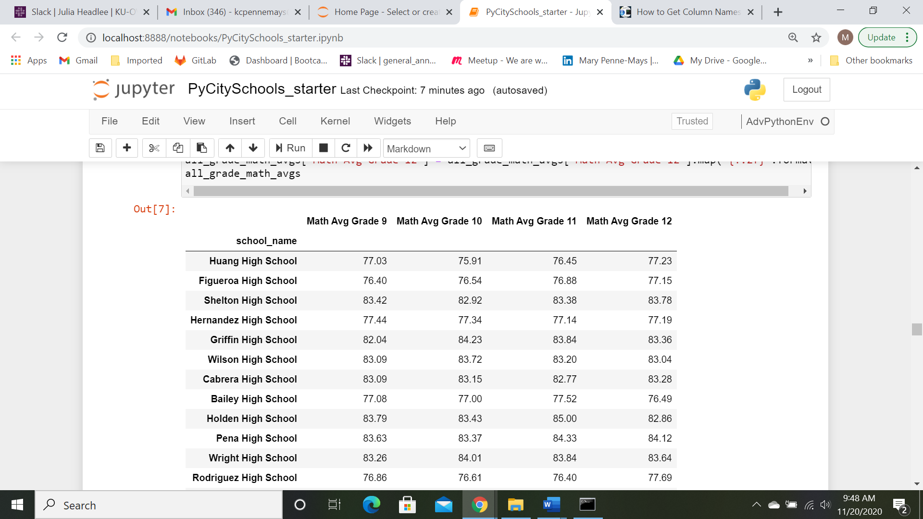

**Reading Scores by Grade**

Reading scores by grade also appear reasonably level from year to year.

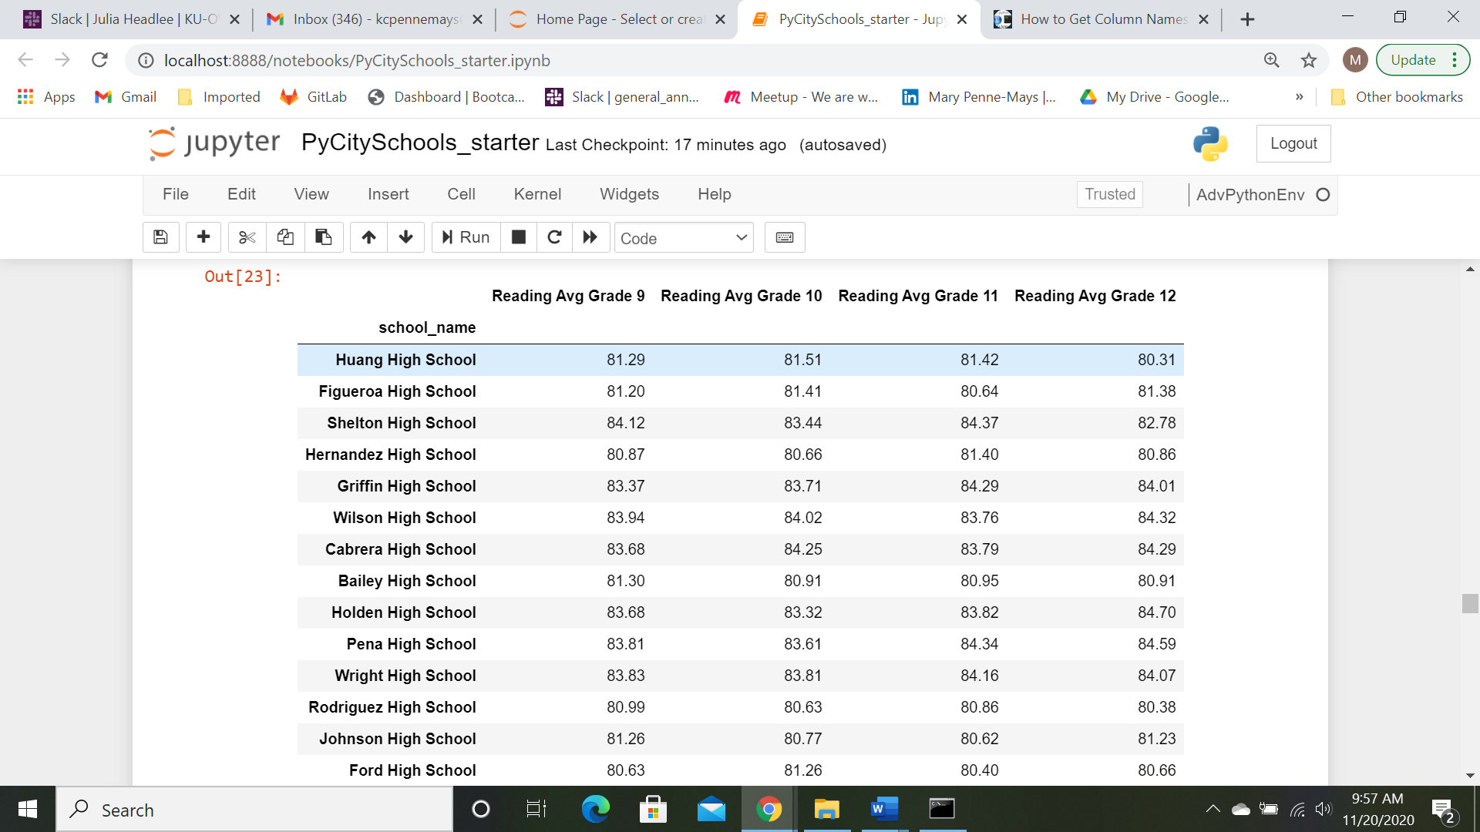

**School Performance by Spending**

There does not appear to be a wide difference in the amount spent per student between schools. The spending amount alone does not appear to affect student scores. In fact, as noted previously, the highest performing schools had a lower per student budget than the lowest performing schools., and that is also reflected here.

Spending Level Math Avg Reading Avg

0 <$600/Student 83.44 83.89

1 $600-625/Student 83.60 83.93

2 $625-650/Student 78.03 81.42

3 $650-700/Student 76.96 81.06

**School Performance by Size**

School size does seem to impact student performance, with smaller schools performing better.

Further analysis to look at other factors may help in understanding the influence of school size.

This may also provide direction on possible school redistribution.

School Size Math Avg Reading Avg

0 <1000 Students 83.82 83.93

1 1K - 2K Students 83.37 83.86

2 2K - 3K Students 78.43 81.77

3 3K - 5K Students 77.06 80.92

**School Performance by Type**

It has already been seen that Charter schools rank higher in scores than District schools.

Additional data may help to understand these results:

* Level of staff training
* Special needs programs
* Class size
* Parent involvement
* Student/family demographics

School Type Math Avg Reading Avg

0 Charter 83.0 84.0

1 District 77.0 81.0